21. Merge Two Sorted Lists
Easy
5964711Add to ListShare
Merge two sorted linked lists and return it as a sorted list. The list should be made by splicing together the nodes of the first two lists.
Example 1:
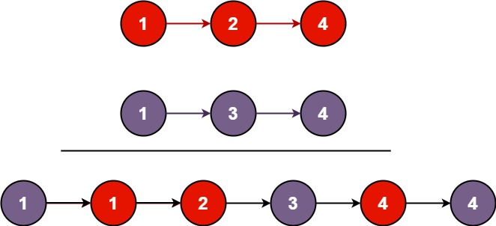

Input: l1 = [1,2,4], l2 = [1,3,4]
Output: [1,1,2,3,4,4]
Example 2:
Input: l1 = [], l2 = []
Output: []
Example 3:
Input: l1 = [], l2 = [0]
Output: [0]
Constraints:
- The number of nodes in both lists is in the range [0, 50].
- -100 <= Node.val <= 100
- Both l1 and l2 are sorted in non-decreasing order.

